Technical Delivery Roadmap for the Nursing Assessment Platform
Implementation sequence from clinical definition to validated operation
Purpose. This document explains the ordered technical route for delivering the nursing assessment platform. It focuses on what the team should complete first, what each stage enables, and which evidence is required before work moves forward.
Core conclusion. The platform should progress through eight controlled stages. Clinical scope and assessment data must be stable before agent behavior and software services are built. Interfaces follow the service contracts, validation follows integration, and production operation begins only after technical and clinical gates pass.
8 | 2 | 1 | 4
delivery stages | primary user groups | structured clinical record | release quality gates
Prepared for product, engineering, clinical, and delivery stakeholders
September 2026

Roadmap at a Glance
The sequence below is a delivery roadmap. It shows dependency and progression rather than software component relationships.
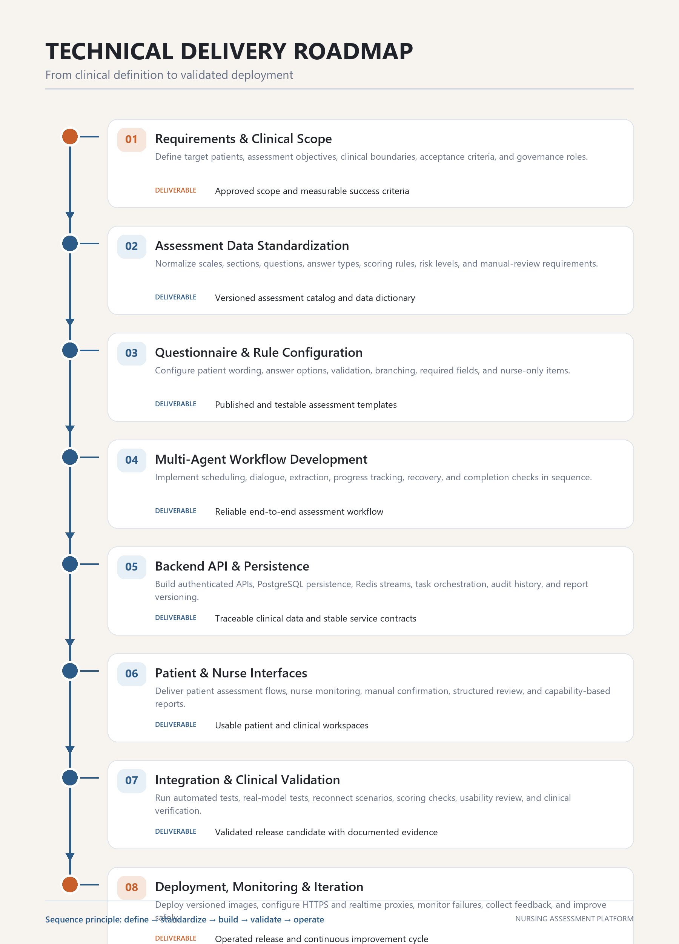
Figure 1 Technical delivery sequence for the nursing assessment platform

Delivery Stages 1 to 2

01 Requirements and Clinical Scope
Objective Define the clinical purpose, target users, operating boundaries, and measurable acceptance criteria before any implementation begins.
Key activities
- Identify the patient groups, admission scenarios, and nursing workflows covered by the first release.
- Define which assessments are completed by patients, AI, nurses, or a combined workflow.
- Agree on safety boundaries, manual review rules, privacy requirements, and escalation responsibilities.
- Translate clinical expectations into observable product and quality criteria.
Deliverable | An approved scope statement, prioritized use cases, clinical ownership map, and measurable success criteria.
Exit gate | Clinical and product owners agree on what the release must do, what it must not do, and how completion will be judged.

02 Assessment Data Standardization
Objective Create one consistent representation for scales, questions, answers, scoring, risk levels, and audit history.
Key activities
- Normalize scale versions, sections, question identifiers, answer types, and option codes.
- Define scoring formulas, interpretation ranges, derived fields, and abnormal-result rules.
- Separate patient-answerable items from nurse-only and manually confirmed items.
- Document the data dictionary and versioning rules used across all services.
Deliverable | A versioned assessment catalog and data dictionary that can be imported, tested, and audited.
Exit gate | Every required field has an owner, type, validation rule, scoring rule, and stable identifier.

Delivery Stages 3 to 4

03 Questionnaire and Rule Configuration
Objective Convert the standardized catalog into patient-ready and nurse-ready assessment templates.
Key activities
- Write natural patient wording while preserving the clinical meaning of each item.
- Configure answer options, required fields, branching, validation, and follow-up conditions.
- Mark nurse-only questions and define how pending manual items appear in patient and nurse views.
- Publish controlled template versions and test deterministic import behavior.
Deliverable | Published assessment templates with validated wording, options, rules, and manual-review settings.
Exit gate | The same template produces consistent questions, answers, and scoring in both AI dialogue and traditional questionnaire modes.

04 Multi-Agent Workflow Development
Objective Implement the ordered agent workflow that prepares questions, conducts dialogue, extracts answers, tracks progress, and verifies completion.
Key activities
- Build scheduling logic that provides the relevant remaining assessment items.
- Implement natural dialogue behavior with controlled tool access and clinical boundaries.
- Extract structured answers from patient language and validate them against the active template.
- Add reconnect recovery, remaining-question restoration, and authoritative completion checks.
Deliverable | A reliable end-to-end assessment workflow with clear agent responsibilities and recoverable state.
Exit gate | The workflow does not repeat completed questions, does not skip required questions, and cannot end before structured progress is complete.

Delivery Stages 5 to 6

05 Backend API and Persistence
Objective Provide durable, authenticated, and observable services for assessment execution and reporting.
Key activities
- Implement task, session, questionnaire, extraction, review, and report APIs.
- Persist clinical facts, messages, submissions, answers, scores, and report versions in PostgreSQL.
- Use Redis streams and workers for realtime events and asynchronous agent processing.
- Preserve audit history, ownership checks, idempotency, and safe error recovery.
Deliverable | Stable service contracts and traceable clinical records that support both realtime and historical workflows.
Exit gate | Every patient-facing result can be traced to a versioned template, source message, structured answer, and responsible workflow step.

06 Patient and Nurse Interfaces
Objective Turn the backend workflow into clear patient interactions and efficient nurse review tools.
Key activities
- Deliver patient login, task access, questionnaire, voice dialogue, text fallback, and completion states.
- Deliver nurse task management, realtime monitoring, manual confirmation, formal review, and quality assessment.
- Present patient condition summaries, capability overviews, and complete question-level results in reports.
- Keep API and mock behavior aligned while showing only real persisted clinical facts in API mode.
Deliverable | Usable patient and nurse workspaces that expose the right information at the right stage.
Exit gate | Representative users can complete and review an assessment without hidden states, ambiguous actions, or unsupported data.

Delivery Stages 7 to 8

07 Integration and Clinical Validation
Objective Prove that the complete system is technically reliable, clinically coherent, and usable before release.
Key activities
- Run unit, integration, repository, API, and end-to-end regression tests.
- Test real language and realtime voice models, disconnect recovery, timeout handling, and duplicate-event protection.
- Verify scoring, risk interpretation, manual-review behavior, and report traceability with clinical reviewers.
- Validate desktop and mobile workflows with representative users and realistic task data.
Deliverable | A validated release candidate with test evidence, clinical sign-off, and documented residual risks.
Exit gate | Critical workflows pass agreed acceptance criteria and no unresolved issue can compromise patient safety or data integrity.

08 Deployment Monitoring and Iteration
Objective Release the validated system safely, observe real operation, and improve it through controlled change.
Key activities
- Build versioned production images and deploy through the approved HTTPS reverse-proxy architecture.
- Monitor API errors, worker failures, realtime disconnects, model behavior, latency, and storage health.
- Collect nurse and patient feedback, classify defects, and prioritize measurable improvements.
- Release changes through repeatable testing, review, versioning, and rollback procedures.
Deliverable | An operated release with monitoring, support procedures, feedback channels, and a controlled improvement cycle.
Exit gate | The production service is observable, recoverable, supportable, and ready for the next validated increment.

Execution Rules and Quality Gates
The roadmap is sequential, but limited overlap is useful when an earlier stage has produced a stable contract. The rules below prevent downstream teams from building against assumptions that are still changing.
Clinical facts before model behavior. Questions, options, scoring, manual-review rules, and completion criteria must be explicit before prompts or agent policies are finalized.
Contracts before interfaces. Frontend work may prototype layout early, but production behavior should depend on reviewed API contracts and persisted facts.
Structured progress before completion. A dialogue cannot declare an assessment complete until all required patient-answerable items have valid structured answers.
Evidence before release. Automated tests, real-model tests, clinical review, and operational checks must produce reviewable evidence before deployment.
Observed operation before expansion. New scales, workflows, and models should be added only after monitoring and user feedback confirm that the current release is stable.

Recommended release evidence
- Approved clinical scope and versioned assessment catalog.
- Traceable test results for scoring, extraction, recovery, completion, and access control.
- Clinical review of representative completed assessments and generated reports.
- Desktop and mobile usability checks for patient and nurse workflows.
- Deployment configuration, monitoring coverage, rollback procedure, and ownership contacts.

How to use this roadmap
At the start of each stage, confirm that the previous exit gate has passed. During the stage, track the listed activities and produce the named deliverable. At the end, review the exit gate with the responsible clinical and technical owners. Any failed gate returns the work to the stage that owns the missing evidence.

